FilmTrain in the Visionpool
- introducing and evaluating a tool for creative problem solving

by: Jannick Kirk Sørensen

Look at this picture! What does it represent?



Feel free to make your associations! My answer is that it represents what you think it should represent. You are adding meaning to the picture as you look at it. It self the picture does not mean anything. The picture is a ‘visual sample’; it is one out of several hundreds of visual samples from a creative tool called “Visionpool”.

What is Visionpool?

Visionpool is large collection of different visual expressions. It is being used whenever a group of people has to agree on the ‘look and feel’ of e.g. a future TV production. The problem Visionpool aims to solve is that everybody in the group has their individual inner visions which are difficult to convey in spoken language. When one mention a notion something else is being imagined by the other group members – the more abstract notions, the bigger deviation in imagination. The simple idea behind Visionpool is to use pictures to talk about pictures. Visionpool is a communication tool easing the conversation by providing visual examples.

Visionpool consists of +500 different visual expressions; styles, colours, shapes, textures and some recognizable objects, but the motifs are intended to be as open for interpretation as possible. Each visual sample is a cardboard piece and in a workshop setting participants search and present the visual samples to each other. The overall goal for the group is to search the Visionpool collection and agree on a few visual samples to represent the group’s idea.

Visionpool is developed by a production designer, Villads Keiding in cooperation with me, an interaction designer and media producer. Starting point was the potential misunderstandings which arise in a TV production process whenever a set designer or production designer has to bring life and visual properties to the words of the journalist. Visionpool is now applied in development processes in Danish Broadcasting Corporation (DR). But Visionpool has shown to be relevant in many other contexts: brainstorming, idea development, strategic development, team building etc. and workshops within these areas has been held.

In conversation with material and situation

The creative process of filmmaking or any other aesthetic artistic based media is renegotiating visions and expectations; there is no ‘correct’ solution to the problems. Any attempt to formulate a problem in a straight logic manner excludes emerging properties which is essential to the artistic process; the effect of making a montage of two pictures and some music is not predictable. Other means and methods are needed than those of a rational deduction or imperative logic. Filmmaking appears more to be an iterative process of considering various possibilities and actions, testing out, exchanging an re-formulating the problem; an art ‘conversation’.

Professor of City planning, MIT, Donald A. Schön develops in his book “The Reflective Practitioner” how not only artists but a broad variety of professions like psychologists or architects do not solve problems in discrete logic steps but work a process which seen from the outside looks messy and opaque. He describes their work as a dialogue the ‘material’; the ‘material’ here understood as the discrete elements of possibilities of actions. This ‘material’ could all kind of representations; for the architect sketches and building modules of models, for the psychologist the client’s phrases and possible interpretation schemes etc. Schön expands the notion ‘problem solving’ to a ‘conversation with the material and the situation’ – the framework and analyses are be iteratively revised during the work.

In the following I will analyze my observations from the FilmTrain workshop, along with interviews with the participants according to the framework Donald Schön. Can the Visionpool samples serve as a ‘conversation tool’ in the FilmTrain participants creative work? To what extent limits or facilitates the constraints given by the properties of this tool the creative process?

Visionpool at FilmTrain

FilmTrain is a two year educational activity with the aim of strengthen 12 South-Danish and North-German film documentary directors through professional production of documentary films.
At a FilmTrain seminar in October 2004 each participant was given the task to make a ‘Visual Proofreading’ of their film projects which at that time were only on at planning stage. The idea was to let the participating documentary filmmakers establish an operational visual concept for the shooting of their film productions.

Villads Keiding was invited as a workshop leader to conduct a Visionpool workshop in October 2004. The workshop was structured as a process in seven steps where the participants searched among 450 Visionpool samples to represent their film with five chosen samples, keywords and a written sentence. Participants pointed out keywords from their project description, found visual samples to represent each other’s keywords, created collectively a visual composition, reduced again the number of used samples and presented finally five samples along with a written sentence composed out of keywords to represent the film idea.

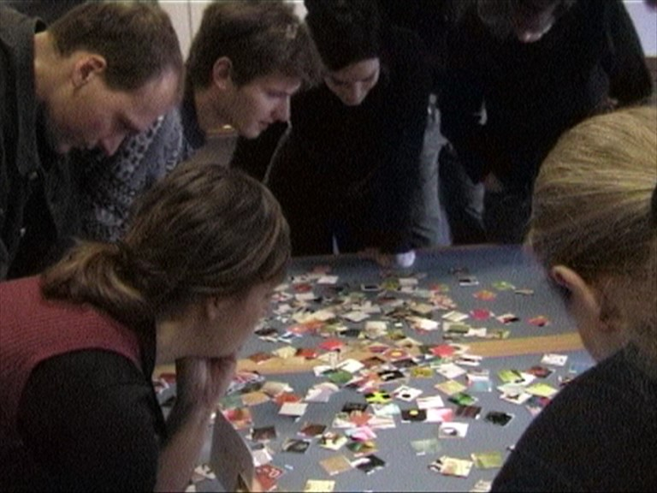
Searching for visual samples to match the keywords

In this essay I evaluate the Visionpool workshop at FilmTrain. Two perspectives are applied; how the FilmTrain participants assess the Visionpool workshop and how Visionpool can be understood and compared as a tool for creative problem solving in a theoretical framework. I interviewed six of the 12 FilmTrain participants in April 2005, approximately six months after the Visionpool workshop. The participants was asked to reflect on their impressions from the workshop. They were then shown the chosen visual samples and asked to reflect on the process working with the visual samples and the eventual impact on their project.

Creativity set free: Liberating the imagination

The Visionpool workshop was prompting participants to redescribed their project in the new ‘vocabulary’ of Visionpool; the collection of 450 visual samples. The participants report that the appreciated the opportunity to look at their film project ‘with other eyes’.

Moses: It was fun because it was creating order in a big mess. It did give you the feeling at that moment that you had a film together, at least what it were going to look like.

Peter: It was a totally other way to look at the film. (…) We were being forced to think in visual ways to organize the material. Until that point we had been very oriented towards words.

Uli: (…) this brought the project further because there was a kind of allowance that one can trust in the colors and in the forms as well. Another aspect of this workshop was that it was practical and nice to have something to play around with, like a child playing with cards, just dealing with feelings, it got a very low stress tension; you could try it out and change it.

Uli’s five
 | 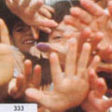 |  | 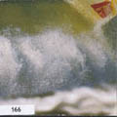 | 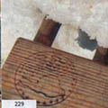
# 456 | # 333 | # 371 | # 166 | # 229
The act of reformulating the projects with new means liberated participants’ creative process, removing some fear of ‘doing the right thing’. The visual samples served as a personal abstract representation of the films and gave the participants a feeling of overview. In this sense the visual samples served as temporary language for creating conceptual and visual based frameworks and this allowed participant to try out ideas.

Colours and shapes

The visual samples have no fixed or imbedded meaning; meaning is assigned whenever a sample is used. At the FilmTrain workshop participants were asked to find, select and present visual samples in three steps: as a description of the film’s content, it’s visual expression and the fusion of those two. Along with the samples participants also presented keywords and sentences constructed from keywords to each other.

As the +450 Visionpool samples however does not contain all possible pictures in the universe, participant were forced to translate their visions into the available vocabulary of Visionpool. In other cases participants found new aspects of their films as they considered samples which intuitively appeared attractive. Thus searching the Visionpool is an alternation between searching for known visuals based on individual visions and assessing the actually found visuals based on the available visual samples.

To Anne the abstractness of the samples helped her getting braver in her artistic choices in her film about language and identity at the Friisian island of Sylt.

Anne: “It’s the colors of the samples, which do stimulate my senses and my view. I like the idea of more abstract pictures, because the spectator can find himself in a broad field with more space for his own interpretation. Visionpool offered me a chance to become braver – “unfocusing” instead of “focusing” concerning the visual approach of my film: This reduction in material offers more space for fantasy.”

Anne’s sentence: “When I look at the horizon at home at the island I realize that our mother tongue keeps us in unity”
 | 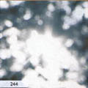 |  | 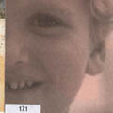 | 
#310  this is the HORIZON | #244  this is my association to HOME – it is reflections on water | #432  this is REALIZATION, which I find is a real abstract process. You feel more than you actually can see. | #171  this is the MOTHER TONGUE, which you learn as a kid. | #301  and this symbolizes UNITY

Moses’ film portraits a DJ and his relation to his hippie parents:

Moses: I do remember colors and structures. I can’t even remember what was on my cards. But it was certain emotions these cards gave me which I thought coincided with the film, (…) what am I trying to achieve emotionally with my film.

Moses’ sentence: The Schleswig Holstein Teenage DJ finds order in mixing urban hip hop beats setting him off his caravan childhoods and his Danish school education
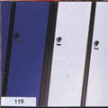 |  |  |  | 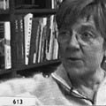
#119  - the blue clean nice coolness of Denmark. Danish schools | #142  - cartoon style of the film, sexy youthful, record covers | #144  - country side of Schleswig Holstein where protagonist lives | #262  - cartoony style of the film | #613  - the mother

In Peter’s film about forty persons sharing a life in a socialist collective in the 1970’ies, warm and red colors played an important part in a both sensuous and symbolic way:

Peter: I was very occupied of those colors, I would like to make the film in some similar colors. It was in the autumn.. I think the leaves were still left on the trees. The first test shooting was done while there still were some good colors. When the winter came and everything was pale I remember that I missed the warm colors. (…) The political color [of the “2nd of October community”, the subject of Peter’s film] was red – warmth and solidarity which was also characteristic of the Community. The gray and hard ones – that was when the opposites became prominent and the community was dissolved.

Peters final five samples
 | 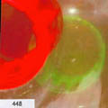 |  | 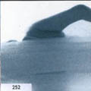 | 
#323  - optimism | #448  - opposites, green = hope | #341 | #252  - individual’s attempt to survive in the group | #380  - new hope / new life

But to Peter also the metonymic value of the samples in relation to the story of Peters film about mentally surviving as an individual in 1970’ies commune were important:

Peter: The foetus was ‘new hope’, the swimming person was ‘fight for survival – in the community’; I experienced it was a struggle to survive. And the colours meant ‘solidarity’.

The reader may find it difficult to assess the selection of samples and the presentations as they refer to participant’s projects in a very detailed way, but I hope the quotes and examples yields an impression on the usage of Visionpool.

In the following I will place Visionpool in a context of other concept design games, analyse Visionpool as a communication tool and analyse participant’s critical comments to Visionpool.

Sources of inspiration

Individual and collaborative problem solving

Filmmaking is an individual and collaborative act of communicating and solving badly formulated problems. ‘Individual act’ as filmic ideas often has a individual perception, opinion or sensation as driving force. A ‘collaborative act’ as the filmmaker has to not only communicate the idea to a film crew; photographer, sound person, editor etc, but also to an audience which has to complete the film by viewing it. It is a ‘badly formulated problem’ as the problem framing, its expression and its content changes as new material is recorded. An initial manuscript can only be a utterance on inspiration and intention. So how imagine a film which is non-existing and which will change shape during the course of work?

A trip into the Klondike possibility space

Imagining a non-existing film bears resemblance to what David Perkins describes as the problem of ‘breakthrough thinking’; how to solve enigmatic problems which cannot successfully be divided in discreet sub-problems. In his book “The Eureka Effect” he compares this type of problem solving with the gold diggers search for gold nuggets in wilderness of Klondike, Alaska, USA 1897-99. Essentially the gold digger did not know where to search in the enormous waste land: it was a wilderness of possibilities, he would hang out in clueless plateaus which does not point anywhere, he may pass through a narrow canyon of exploration where he omit many other possibilities or he would end up in an oasis of false promise where a few positive indicators may keep him stay too long.

Today’s complex problem solving and decision making bear resemblance to the gold diggers search; according to Perkins “Any process of problem solving can be analyzed as a search through a space of possible approaches and partial solutions - in a possibility space for the problem” [2, p. 48-49]. What makes breakthrough problems special is their structure which makes sequential (deductive) reasoning impossible. Perkins thus suggests four search strategies: Roving; “to move around in the space of possibilities, looking here, looking there, not lingering in any one place”, Detecting hidden clues: “Although there do not appear to be clues, perhaps there are”, Reframing: “When a search appears to be going in circles, the problem solver should investigate how tacit assumptions, descriptions of the situation (…) are constraining the search within a limited region.” Decentering; “backing up to an earlier point and taking a different path from there, (…) by broadening or changing the problem definition”, [2, p.53-55].

As the reader may see ‘Roving’ and ‘Reframing’ is taking place at the FilmTrain Visionpool workshop; ‘Roving’ as the participants are physically searching a vocabulary of visual statements with semi-fixed meanings, ‘Reframing’ as the participants are asked to describe their film through this vocabulary and five keywords; a new way of describing a film. As the search process is not a 1:1 translation of ideas, the task too implies a forced decentering. The reader may also note how the concept of ‘decentering’ is similar to Donald Schön’s notion of practitioners work as a ‘conversation with the material and the situation’; the situation and the material ‘talks back’ as the practitioner discovers what a certain solution implies and this dictates conditions for the continued work.

Concept design games

The frameworks of Perkins and Schön consider mainly the individual creative problem solving. In collaborative problem solving idea representation and communication gets essential. Getting a shared understanding of concepts outside the realm of words does not only apply to filmmaking; architects, musicians, industrial designers and those professions communicate by examples, specimens and prototypes.

Visionpool is inspired by a research project at MIT, Department of Architecture, in the mid-1980’ies. A group of researches around N. John Habraken was researching on the complex design process of architecture. Designing a building includes many people; a number of ‘stake-holders’ with different expertise and agendas are negotiating and influencing the design decisions.

“Designing is a social activity that takes place among people who negotiate, make proposals, set rules for their conduct and for the work to be done, and follow such rules.”

In order to observe and understand the simultaneous and complex decision-making processes in architecture the MIT researchers decided to try to model specific parts in abstract formalized models. They found that board games could serve as a conceptual framework:

“As when designing, players must fit pieces into an existing field; rules, conventions, and principles limit how they may move: and they make flexible, negotiable arrangements about what conventions and rules to use in a given situation. Last but not least, players make projections for configurations to be constructed.”

The researchers invented nine concept design games, which were not ‘games’ in a classic sense as there were no clear winning condition; but rather a kind of puzzles or ‘language games’ in a Wittgenstein sense. One of the games – The Silent Game – deals specific with examining the non-verbal design communication between the participants; they are not allowed to talk but are forced to show it through a uniformed design material like LEGO™ bricks.

Concrete or abstract game pieces?

”In principle, design games can be played with any set of pieces. (…) As with all board games, what the pieces are made of is of secondary importance, although individual players may have strong preferences.” Habraken, N. John & Gross, Mark D. (1987) Concept Design Games. p. 4-2

In one aspect Visionpool differs dramatically from the MIT Concept design games; where the MIT Concept design games used uniform game pieces like washers and nails or LEGO pieces, the Visionpool uses visual samples with individual and distinct aesthetic expressions and too, an interpretable reference to the surrounding world. This implies – I will argue – that with pictures on the game pieces it is more difficult to trespass blocking mental frameworks than with pure abstract game pieces. In this sense Visionpool is a less formalized and less ‘open’ design game as the MIT Concept Design Games .

With recognizable game pieces as in Visionpool the cognitive search strategies applied by the participants do influence the development of ideas; if a participant exclusively search for metonym representations of already known core concepts, these are not being challenged. However Visionpool with its lack of iconographic pictures does not support the direct translation from keywords to samples. In this sense Visionpool is deliberately an ‘awkward’ instrument in the creative process, forcing participants into unknown aspects of their ideas and visions.

With pure abstract uniformed game pieces, like the LEGO-bricks of “The Silent Game” the search and negotiation will not be stimulated to the same degree. The property of the game board pieces as ‘place-holders’ for ideas will too be diminished, while potentially the freedom of leaving fruitless mental frameworks would be bigger. Visionpool game pieces thus oscillates between being abstract and concrete game pieces; as representations of core concepts and place-holders for loosely formulated perceptions.

You can’t win a Visionpool game

A Concept Design Game is not a game. There is no way you can state ‘I won’. Maybe you will get the chilling sensation of a new insight or a bright idea, maybe the sheer feeling of solving puzzle but it is not a game. The result is however being judged in the social setting of colleagues and peers; and customers. Comments from participants support the interpretation of Visionpool as play:

Moses: What makes things playful? ‘Playful’ is when you try things without running into any big risks.

Uli: It was very inspiring (…) to have this huge amount of different styled cards which took you out of your closed view and opened you up for… ‘Oh this is possible! It can be really funny or It can be really hard, powerful, strict’. It opened up the mind for different styles.

The game theoretician Johan Huizinga, writes in 1938 about the ‘play’ aspect of culture:

“[Play is] a free activity standing quite consciously outside “ordinary” life as being “not serious”, but at the same time absorbing the player intensely and utterly. It is an activity connected with no material interest, and no profit can be gained by it. It proceeds within its own proper boundaries of time and space according to fixed rules and in an orderly manner. It promotes the formation of social groupings, which tend to surround themselves with secrecy and to stress their difference from common world by disguise or other means”

The Visionpool workshop has many similarities to what Huizinga defines as ‘play’; it is outside ‘ordinary life’ as it to the participants is an unknown and unexpected way of working with project imagination. It is not being ‘serious’ as decisions during the play can be undone without external consequences. There is no direct winning condition, but competition may however occur due to the social structure of the group, but this competition takes place on a social meta level of the actual play with Visionpool. However it does not have ‘its own proper boundaries of time and space’ as a workshop leader is guiding the schedule. So is the constellation of the groups; they do not dynamically change but are formed initially, in this case by the workshop leader. In Huizinga’s expressions ‘secrecy’ and ‘difference from common world’ a perception of hierarchical organisation of activities is embedded; a notion which is not necessarily reflected in today’s organisational teamwork, but in the case of a groups collaborative work with Visionpool in fact a shared understanding is established which can be incomprehensible to foreigners. No disguise needed; the problem is to preserve and communicate the insights acquired by the group.

In one case the use of Visionpool as a tool in creation process of may even be said to by-pass the burden of social expectations:

Uli: Another aspect of this workshop was that it was practical and nice to have something to play around with, like a child playing with cards, just dealing with feelings, it got a very low stress tension; you could try it out and change it. It was fun. (…) You didn’t have to be full responsible for the result, you only had to play around and talking about your project. In other cases – even in FilmTrain - the question was ‘Can I develop something which is good, professional, says something specific?’. Just playing around with these cards was like: You will find a result, it is no problem.

Also the physical properties of the samples and the game board may be part of the play qualities; with the samples it is possible to construct manifest representations of something yet very abstract; the film. The samples serves as building blocks and the workshop rules and the game board as scaffold for the construction and reconstruction of participant’s visions of their films. A scaffold which does not limit but facilitates development.

Properties of Visionpool as a Concept Design Game

What is a good Visionpool sample?

Could any kind of pictures have been used for the Visionpool? I doubt. I believe that in editorial process of choosing candidates for visual samples performed by Villads Keiding and me an intention is imbedded of ‘not making it too easy’ to translate from inner ideas to visual samples. We deliberately omitted pictures we found to be easy to ‘interpret’, pictures which are ‘dead metaphors’; icons of our culture we do not any longer discuss or find controversial.
#613

Sample # 613 used by Moses, is a example of a Visionpool sample not working to a Danish audience. The face will - I guess - unmistakably be recognized as the member of Parliament, Marianne Jelved. However to a German the visual sample works as an abstract but still visually concrete representation, in this case used to signify of ‘the mother of the protagonist’.
Samples like # 613 are not useful as one interpretation dominates all other possible interpretations; when first recognized with one strong meaning, it looses its ambiguous properties, it can hardly serve as representation of something else. Visionpool is intended to be a tool for communication, and thus would the language break down if it starts to favor some interpretations in spite of others.

I would claim that Visionpool samples only serve as abstract place-holders for ideas during a creative process; when the process has been finished the sample is in principle ‘void’. For this reason we deliberately try to avoid samples which are having too strong specific connotations. The visual sample # 613 has e.g. been omitted in the current edition of Visionpool.

What makes the Visionpool samples special are their ambiguity; as raw material for visual utterances they need to be defined by the context and the person using the sample. The visual properties of the sample set limits to what possible interpretation a social context will accept. The Visual sample is a ‘semi-open’ utterance which carries certain aesthetic properties but call for a completion with context and spoken motivation.

Visionpool samples as opinion markers, gifts or jokes.

A Visionpool workshop does not take place in a vacuum, but the social setting of the group constitutes a framework for the creative process. Important is group members prior knowledge of each other, the demands being posed on the group regarding the result, and finally to what extend the project is shared or not.

My observations from Visionpool workshops show that the samples are being used as markers of ideas. The physical properties of the visual sample and the spatiality of the game board ensures that ideas stays in the mind of the group. Often the motif is being used in as metonymic reference to a real world phenomena. The samples serves as a collective temporary memory by keeping track of the discussion and the task of reducing the amount of samples thus becomes a question of discussing priorities and core ideas.

Placing a sample on the board is also a social statement. It can either be intended as a gift, as a straight or ironic comment to the group, as a provocation, as a ‘position marker’ indicating personal opinions or as a joke to resolve the group’s impassé.
[333]

Kasia: ”This is for you, Anne!” [333]
Anne: “That’s cute!”

Creativity constrained: rule-governed creativity

In many ways “Visionpool” can be said to be a continuation and revision of the MIT concept design games; it tries to formalize - with rules, workshop process and game board pieces - the way ideas are being negotiated both internally by the creator for himself / herself and externally with a group. It is a formalized model of the design problem – the filmmaking. How did the FilmTrain participants react to this formalized creative process?

Words and visions

By re-describing the film ideas with Visionpool samples and keywords participants formalized their descriptions of the films. Participants were initially asked to write five keywords describing their project. The keywords were subsequently handed over to other participants to form search criteria for the visual samples. Later in the workshop participants were asked to construct a sentence out of the keywords to describe their film project. Keywords served thus throughout the workshop as pivotal points of the creative work. This, however, created a conflict between words and visions:

Peter: It was indeed irritating.. Relating to the five words forced you constantly to find out whether they fitted to what you would like to tell. I had problems to surrender and leave the realm of words. You could say that we were just asked to find some visual samples and say ‘That’s it!’. But we were constantly asked: “How?”, trying to interpret it. The others should also interpret it, so in that way the realm for words was present all the time.

Also Friederike, making a portrait of three 30-year old women being stuck in life, commented on the task of having keywords as guide lines:

Friederike: I had big problems with the sentence I wrote during the Visionpool workshop. The focus was set on the word "friendship" and I was sure that this was not what I wanted to talk about in my film. After the shooting I found out, that most parts of my film are about "friendship". The sentence forced me to reduce my thoughts to one basic idea, maybe like this I found out that my protagonists are really good friends.

Another participant, Kasia, who’s film deal with the question of personal identity and Polish roots, reports that words in general is not her main communication channel. She would not on her own initiative had started writing a sentence to describe her film. She thus used the visual samples to represent existing footage from a research trip.

Kasia’s sentence: I had a dream to travel back to find my roots, but the only thing that connect me was the language.
 |  |  | 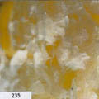 | 
This is the ‘DREAM’ | This is ‘TRAVELING’ – because the horizon is blurred | This is ‘BACK’ because it is nostalgic | This is my ROOTS. There is some piece of paper which said that I had family in Poland, but it is blurred for me | The LANGUAGE – something which is fluent

From the above quotes it appears that keywords not necessarily were the easiest way to redescribe the film projects; participants found matching keywords with samples a difficult task. To some extend the usage of keywords blocked the problem solving. Working in a foreign language did not either ease the participant’s understanding of each other’s projects.

# 366: “flowering” (Anne to Morten)
# 449: “horizon” (Kasia)

#383: “secret” (Morten)

In this case Anne present a sample to represent Morten’s keyword ’Flowering’ from his project of that time about a girl suffering from anorexia:

Anne: ”So I would love to put my ‘flowering’ [#366] here because it is perfectly fitting together with the melancholy of the horizon [Kasja’s sample #449] and your ‘secret rose’ [Morten’s sample #383].
Morten: “Mmm”
Anne: “And what I found nice about this one – there were a lot of other flowers, but this pictorial kind of flower, it so nice that you can do so simple lines, and everybody has to grin a little when he sees this because it has something childish, something naïve which I like about flowers and that make you laugh. This is what it did even it is a little melancholic.”
Morten: “Yeah… “
Anne: “… and nice”
Morten: “But … øh… is ‘flower’ and ‘flowering’ the same?”
Anne: “I thought about it, I mean I thought ‘flowering’ means ..eh eh.. something like ‘Blumig’ (german), I don’t what it is in English… Like eh.. It could also be an abstract way of making something really colorful into overdoing a little, right? Or?”
Morten: “Yeah, I was thinking something like ‘growth’,
Anne: “Growing?”
Morten: “…’folding out’ or something…”
Anne: “Ah..! Ok?! Ok.” (quiet) “I didn’t think about that..”

It appears here as if Anne generally are using the samples more as visual expressions in their own right where as Morten tends to use the samples more as metonymic representatives for keywords. Thus the visual and the written languages are clashing; there is no easy cure in combining these two

Visionpool as vocabulary

If we regard Visionpool as a visual vocabulary and the rules for searching, sorting, reducing and selecting a syntax, we can ask if the translation process from participants visions to five samples made sense to the creative process of the participants. Here reactions are, as above quote shows, different.

On the one side was the task of matching already existing visions and in some cases also actual footage with the collection of samples fun because it implied a search for redescription; the selection of the Visionpool samples was not capable of delivering the exact pictures in mind of the participants. The constraints yielded a creative input. On the other side participants did not only having problems with the limited vocabulary of chosen keywords, but also the variety of samples:

Moses: I do remember we were a bit limited in the cards. I remember looking for plant-like shapes, green shapes.. it was more masculine shapes than feminine shapes. I would have liked if the selection was much, much larger.

Friederike: I would be afraid of too many film projects being influenced too much by Visionpool. It should not be a "cooking recipe" which reduces a project in the end to six words and six pictures. We would get bored and we would find out easily what everything is about. I think that every good film has a clear style and idea but there have to be things that disturb, that we don't like, that don't fit into our expectation to make it a really good film. If not, we would have the feeling to deal with a commercial product.

I will claim that the risk is that the translation task becomes a sheer puzzle of combining keywords with samples. The intensive use of keywords constantly forced the participants to leave the visual logic of constructing a coherent visual universe; they were constantly forced to also interpret the samples as metonymic narratives.

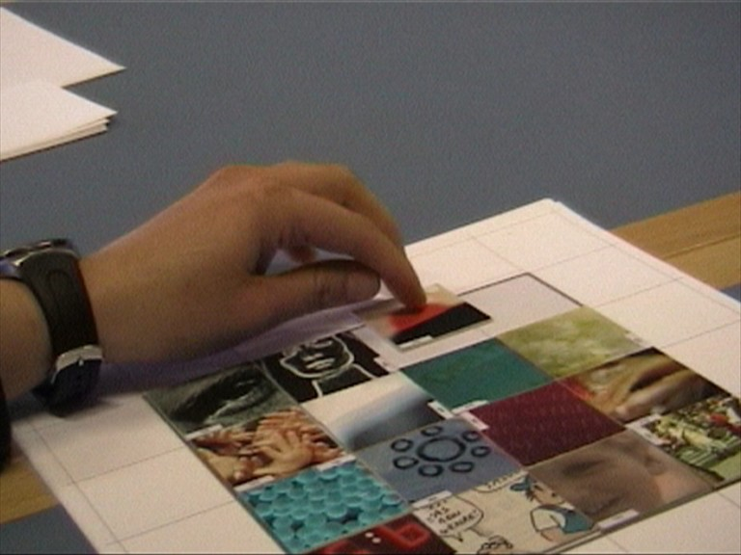
Anne: ”I feel I want to move it into the right composition”,
Morten: ”Yes, it has a lot of jigsaw qualities”
Anne: ”I would love just to go away from the words; just colors and the framings of the pictures, I would love to do the composition a little different.. it’s like its itching in my fingers.
Morten: ”I have it a little differently. I start reading the pictures as it is so for me it can’t be any other way because it has been build like this. I think it will spoil the meaning for me it has right now.”

A Personal Visual Language?

Looking back on the Visionpool workshop some participants emphasize that one outcome from the workshop was getting aware of having a own visual language. The task of expressing your idea through an unknown vocabulary of pictures prompts reflection of possible visual patterns in your selection:

Friederike: I am convinced that every creative person has its own style. (…) Very often our projects and products look similar although we haven't planned it. And after a while you can see a "red line" in your work, your "handwriting". I write this because I want to explain that in my opinion it is no coincidence what kind of pictures you choose out of thousands of pictures. You look for pictures which represent your taste and you keep them only when you have a good feeling with them. (…) It's no surprise than any more when you find out that you can always find your style back in your work. Visionpool shapes your taste and helps you to show it to other people.

Friederike’s final five
 |  |  | 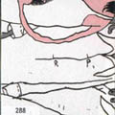 | 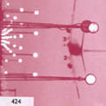
#357 | #180 | #303 | #288 | #424

Also Kasia recognizes her own visual style when she contemplates the visual samples she found. In fact the samples appear very close the visual style of the ‘dream’-sequences of the current film project.

Jannick: What do you think when you see [the final five samples]?

Kasia: That I’ve got a visual language. I could have chosen many other pictures than such blurred, diffuse ones which I’ve got now. It’s funny to see that I’ve got a certain visual language.

Conclusions

The Visionpool workshop proved to be a useful and playful redescription process. It did not significantly influence the content of the film projects, but brought self-confidentiality to the filmmakers. The workshop functioned indeed as a ‘visual proofreading’.

The constraints posed by the Visionpool workshop and the vocabulary of visual samples provoked participant’s communication of their film ideas. The question ‘Is my idea contained within these keywords and visual samples?’ made choices of means and expressions clear to participants. By excluding external parameters and factors participants easier came to terms with core ideas.

Visionpool proves to be a successful continuation of the MIT Concept design games transferred to an other context and significantly adding new qualities by utilizing a certain kind of images and refining the rule-set. The general method of constrained or systemized creative work, or scaffolding the learning process of creating the film, seems promising but methods need to be tailor-made to meet media-specific properties. The benefit of ‘translation exercises’ like assigning keywords and visual samples to an idea depends on the vocabulary at hand and the urge and demand to communicate. In the case ‘FilmTrain’ participants need to communicate ideas were moderate as all projects were individually driven and did not have to compete to obtain financial support. Thus the exercise of redescription became an internal visual proof-reading.

Schön, Donald A. (1983) “The Reflective Practitioner – How Professionals Think in Action” (Basic Books)
Perkins, David (2000) The Eureka Effect. The Art and Logic of Breakthrough Thinking. W.W.Norton & Compagny, New York, USA. ISBN: 0-393-32255-6 (pp. 44-66)
Habraken, N. John & Gross, Mark D. (1987) Concept Design Games. A report submitted to the National Science Foundation Engineering Directorate, Design Methodology Program, June, 1987 Book one: Developing.: Department of Architecture, Massachusetts Institute of Technology, Cambridge, Massachusetts
same as (4)
Huizinga, Johann (1938 / 1955) Homo Ludens. A Study of the Play Element in Culture. Beacon Press, Boston (p.13) quoted from ((4), p. 75)

